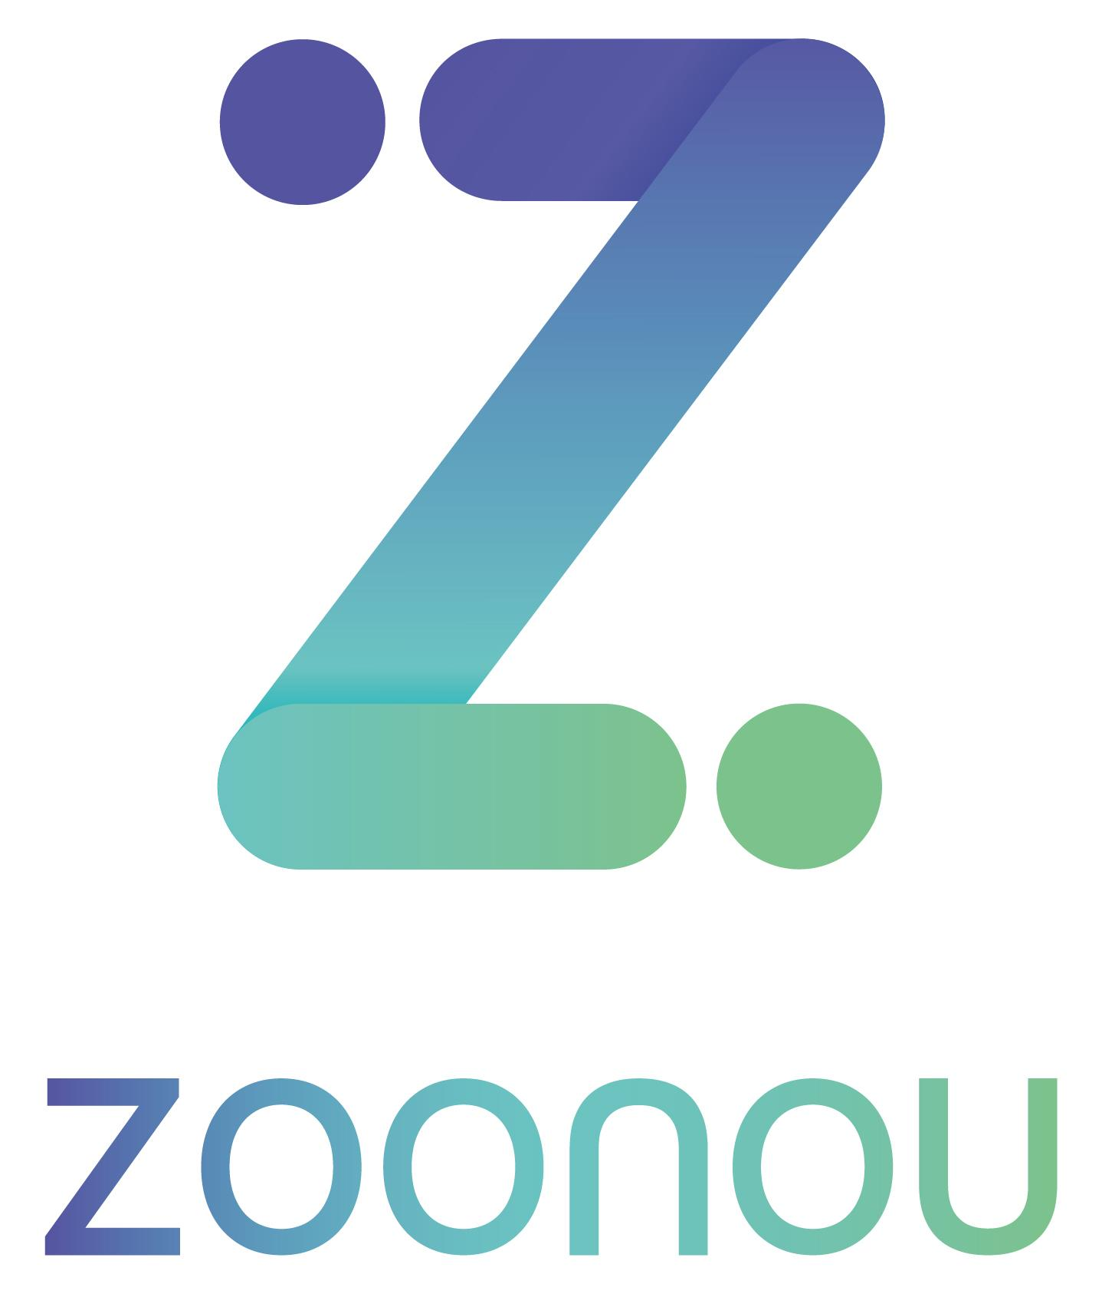

Confidential

Daily Report

Date: | 24/06/2021
Client: | Studio 24
Project Name: | W3C Website
Project Lead: | Harriet Hadley-King - 07943 195087
Testers: | Rupert Garland

Summary

Issue verification was carried out today on the W3C website on behalf of Studio 24. Issues assigned to Zoonou within the ‘On Staging for Review’ column were retested to clarify the previously observed behavior has been resolved, with further regression testing also being completed.

A total of 22 issues have been verified today, 21 of which have been closed and moved to the status of ‘Done’, one ticket has been verified as partially fixed and has been reopened for further investigation. The website has performed well throughout the day of testing with no new issues being raised throughout regression testing.

Of the tickets that were pushed back for further development, as mentioned above one has been reopened due to the ‘Submit’ and ‘Search’ CTAs not functioning as expected, when selected they remain to be inconsistent within iOS Safari environments rendering as a blue colour in the focus state.

Throughout the day of testing the Zoonou raised tickets that have been closed include several rendering inconsistencies, validation checks as well as carousel chevron buttons functioning as expected. During today’s testing one verified ticket was a client raised issue regarding the ‘Business ecosystem carousel’ not resizing correctly when the browser window is resized, this has been fixed and moved to done.

This concludes todays testing where 21 tickets have been verified and closed within the tracker. This brings the total number of outstanding issues to 2. No further testing is currently scheduled at this time.

Test Details

Target URLs: | https://w3c-dev.studio24.dev/
Test Environment(s): | Primary environments:  Windows 10, Chrome 91  Issues were verified in environments tickets were originally raised in

Issue Summery

Issue tracker URL: | https://studio24.atlassian.net/secure/RapidBoard.jspa?rapidView=145&projectKey=W3C&selectedIssue=W3C-277
Blocking Issue(s) found: | N/A
Top 5 issues of concern:
1: | W3C-581 - Form Elements – Buttons Have Inconsistent Selected State
2: | W3C-587 - Business – Carousel Does Not Fit on Screen in its Entirety at Once

Metrics

Overview
New issues raised today: | 00
Issues verified as not fixed today: | 01
Issues closed today: | 21
Total number of outstanding issues: | 02

Ticket Breakdown

Ticket Severity | Tickets Raised
Minor Impact on Functionality | 00
Cosmetic Issue/Typo | 02
Enhancement/Suggestion/Query | 00

Ticket Environment | Tickets Raised
Global | 00
Desktop | 01
Mobile | 01

Ticket Type | Tickets Raised
Functional | 00
Cosmetic | 01
User Experience | 01

