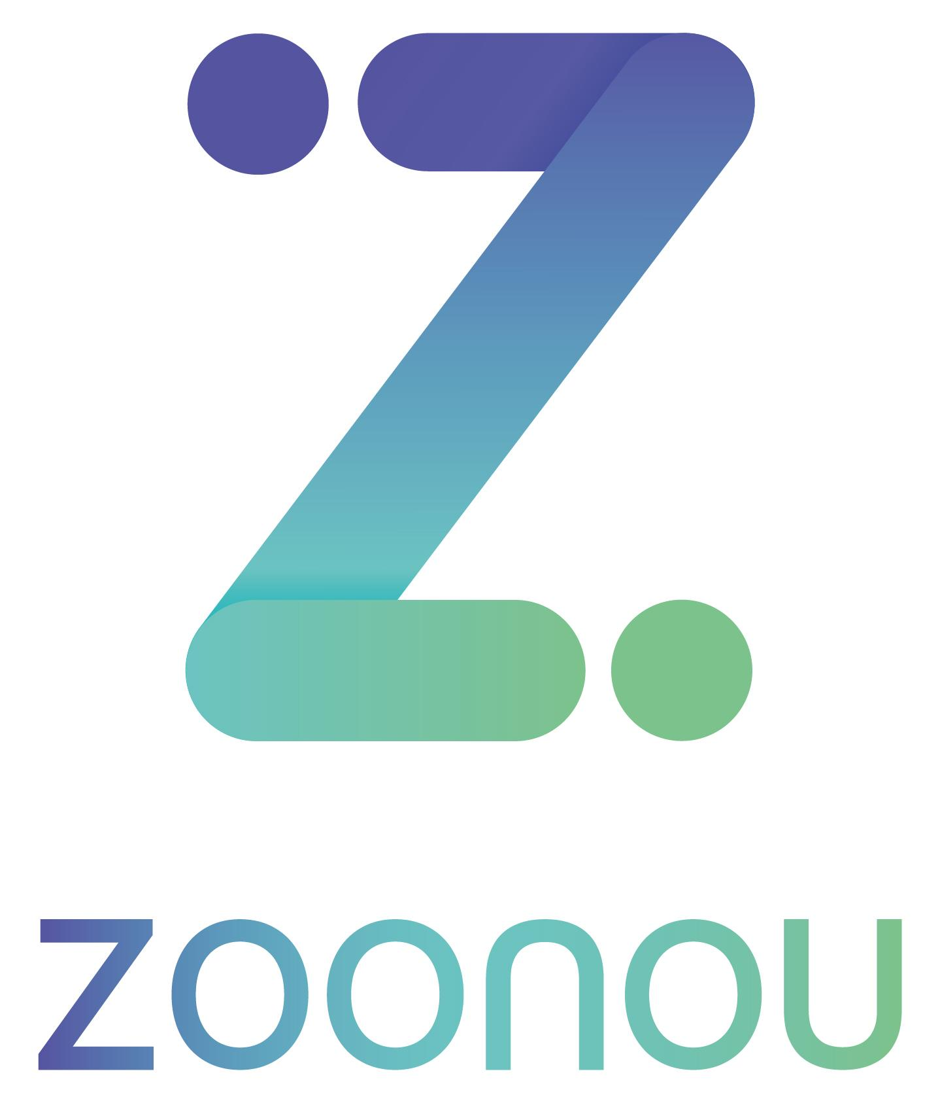

Confidential

Daily Report

Date: | 26/05/2021
Client: | Studio 24
Project Name: | W3C Website
Project Lead: | Harriet Hadley-King - 07943 195087
Testers: | Izi Kimble

Summary

Testing has been carried out today on the W3C website on behalf of Studio 24. The focus of the session has been on testing 11 specified items, each of which is an individual component or template page. Today’s session was spent looking at these items on desktop Chrome. Due to forms not being linked to the back end, functionality related to validation and submission has not been tested.

No major issues have been encountered during testing on the first environment, with the user able to interact with links and functionality in place without issue on most components. Overall, elements have been seen to render as expected, including when the browser is zoomed in and out. When resizing the browser window, side navigation is observed to condense into an accordion at the top of the page.

A total of 7 issues have been identified during the session, three of which are functional in nature. The first relates to links not opening in a new window or tab, despite the presence of the new window icon. Filter dropdowns are also observed to display the current selection only when an option has been selected, and language links present on some pages currently navigate to a 404 error page. Cosmetic issues include filter elements rendering unexpectedly and misaligned elements, and queries have been raised concerning autocomplete and navigation positioning.

To conclude, 7 new issues have been raised today. Testing is scheduled to continue tomorrow, Thursday 27th May, when compatibility testing will commence to explore the components on different screen sizes and browsers.

Test Details

Target URL: | https://w3c-dev.studio24.dev/
Test Environment(s): | Primary environments:  Windows 10, Chrome 91  For cross environment checks, please see the environments detailed below.

Issue Summary

Issue tracker URL: | https://studio24.atlassian.net/secure/RapidBoard.jspa?rapidView=145&projectKey=W3C&selectedIssue=W3C-277
Blocking Issue(s) found: | N/A
Top 5 issues of concern:
1: | W3C-571 - Listing Page – People – Filter Element Displays Current Selection Only in Dropdown
2: | W3C-565 - Listing Page – Posts – In the Media – Link Does Not Open in a New Window/Tab
3: | W3C-566 - [Raised for Reference] Single Post – Language Options Navigate to 404 Page
4: | W3C-570 - Listing Page – People – Filter Element Renders Unexpectedly when Selection is Cleared
5: | W3C-568 - Single Post – User’s Profile Image is Misaligned with Comment Form

Metrics

Overview
New issues raised today: | 7
Issues verified as not fixed today: | 0
Issues closed today: | 0
Total number of outstanding issues: | 7

Ticket Breakdown

Ticket Severity | Tickets Raised
Minor Impact on Functionality | 3
Cosmetic Issue/Typo | 2
Enhancement/Suggestion/Query | 2

Ticket Environment | Tickets Raised
Global | 3
Desktop | 4

Ticket Type | Tickets Raised
Functional | 4
Cosmetic | 3

Test Environment Matrix

Environment | Browser | Primary | Checked | Date
Windows 10 | Edge 90 | No | Partially Completed | 26/05/2021
Windows 10 | Firefox 88 | No | Partially Completed | 26/05/2021
Windows 10 | Internet Explorer 11 | No | No | 26/05/2021
Windows 10 | Chrome 91 | Yes | Yes | 26/05/2021
macOS 10.15 | Safari 13 | No | No | 26/05/2021
macOS 10.15 | Chrome 90 | No | No | 26/05/2021
macOS 10.15 | Firefox 88 | No | No | 26/05/2021
iPhone 8 - iOS 14.5.1 | Safari 14 | No | No | 26/05/2021
iPhone 12 Pro – iOS 14.5.1 | Chrome 90 | No | No | 26/05/2021
Google Pixel 3 XL – Android 11 | Chrome 90 | No | No | 26/05/2021
Samsung Galaxy Note 8 – Android 8 | Samsung Internet (Latest) | No | No | 26/05/2021
iPad 10.2 (7th Generation) - iOS 14.5.1 | Safari 14 | No | No | 26/05/2021

