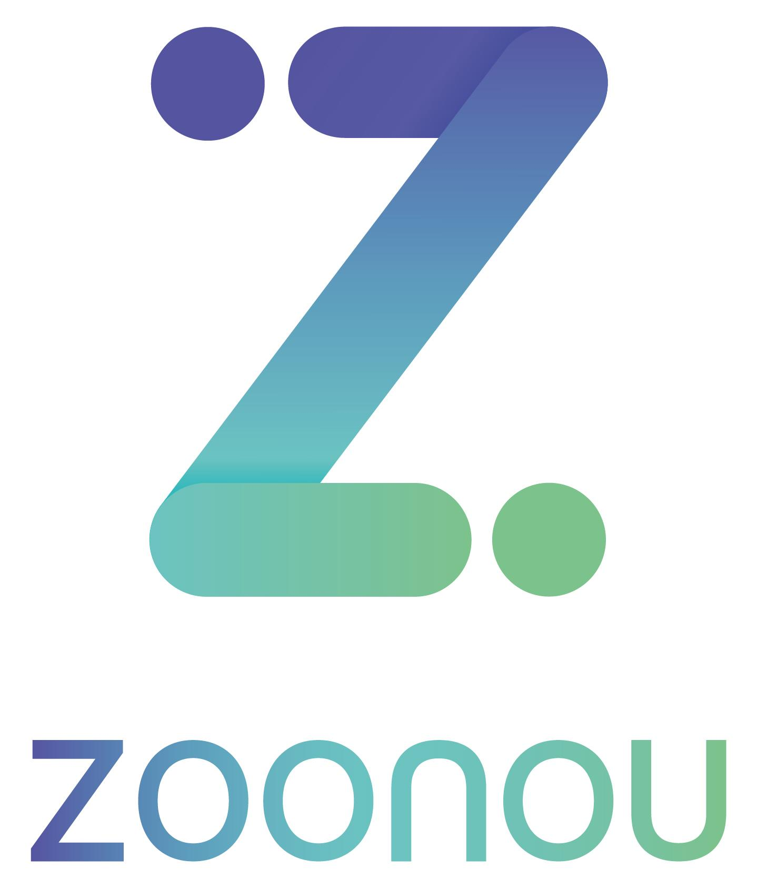

Confidential

Daily Report

Date: | 28/05/2021
Client: | Studio 24
Project Name: | W3C Website
Project Lead: | Harriet Hadley-King - 07943 195087
Testers: | Rupert Garland, Izi Kimble, Jett Nash
Summary

Testing has been completed today on the W3C website on behalf of Studio 24, with a continued focus on compatibility testing across 11 specified elements or pages. This has been performed on 14 additional browser and device combinations, including Android and iOS mobiles and tablets.
The components have been observed to render mainly without issue across the newly tested environments. Three issues were closed as expected behaviour during the session, including a ticket regarding language options navigating to a 404 page, autocomplete not being limited to letters at the start of the dropdown items, and links with the ‘new window’ icon not opening in a new window or tab.
In total, 4 issues have been raised today. Most notably, a functional ticket was raised against the ‘Form Error Messages’ page, where the user is anchored unexpectedly when selecting the ‘Enter a message’ error message. The remaining 3 issues are cosmetic in nature, with the video element becoming misaligned when selecting the ‘Play’ CTA, and the same element rendering with the left edge cut off on iOS environments, as well as dropdown menus not closing when focus is moved elsewhere.
To conclude, 4 new tickets were raised today and 3 have been closed, bringing the outstanding ticket total to 22. Testing is currently scheduled to continue Wednesday 16th of June, when issue verification will commence.

Test Details

Target URLs: | https://w3c-dev.studio24.dev/  https://w3c-dev.studio24.dev/business/index.html
Test Environment(s): | Primary environments:  Windows 10, Chrome 91  For cross environment checks, please see the environments detailed below.

Issue Summary

Issue tracker URL: | https://studio24.atlassian.net/secure/RapidBoard.jspa?rapidView=145&projectKey=W3C&selectedIssue=W3C-277
Blocking Issue(s) found: | N/A
Top 5 issues of concern:
1: | W3C-571 - Listing Page – People – Filter Element Displays Current Selection Only in Dropdown
2: | W3C-573 - Form Elements – Show Password CTA Present on Initial Password Input
3: | W3C-577 - Form Elements – ‘Search’ Element Lacks ‘Clear Input’ Functionality
4: | W3C-579 - Form Elements – Fields Lack Additional Formatting Functionality
5: | W3C-574 - Form Elements – ‘Number of Guest Tickets’ Field Accepts Any Input Type

Metrics

Overview
New issues raised today: | 4
Issues verified as not fixed today: | 0
Issues closed today: | 3
Total number of outstanding issues: | 22

Ticket Breakdown

Ticket Severity | Tickets Raised
Minor Impact on Functionality | 9
Cosmetic Issue/Typo | 11
Enhancement/Suggestion/Query | 2

Ticket Environment | Tickets Raised
Global | 4
Desktop | 10
Mobile | 7
Tablet | 1

Ticket Type | Tickets Raised
Functional | 9
Cosmetic | 12
User Experience | 1

Test Environment Matrix

Environment | Browser | Primary | Checked | Date
Windows 10 | Edge 90 | No | Yes | 27/05/2021
Windows 10 | Firefox 88 | No | Yes | 27/05/2021
Windows 10 | Internet Explorer 11 | No | Yes | 27/05/2021
Windows 10 | Chrome 91 | Yes | Yes | 26/05/2021
macOS 10.15 | Safari 13 | No | Yes | 27/05/2021
macOS 10.15 | Chrome 91 | No | Yes | 27/05/2021
macOS 10.15 | Firefox 88 | No | Yes | 27/05/2021
iPhone 8 - iOS 14.5.1 | Safari 14 | No | Yes | 27/05/2021
iPhone 12 Pro – iOS 14.5.1 | Chrome 90 | No | Yes | 27/05/2021
iPhone 8 - iOS 13.7 | Safari 13 | No | Yes | 28/05/2021
iPhone 8 - iOS 13.7 | Chrome 90 | No | Yes | 28/05/2021
iPhone 7 Plus - iOS 13.7 | Chrome 90 | No | Yes | 28/05/2021
iPhone 7 Plus - iOS 13.7 | Safari 13 | No | Yes | 28/05/2021
Google Pixel 3 XL – Android 11 | Chrome 90 | No | Yes | 28/05/2021
Google Pixel 4XL - Android 11 | Chrome 90 | No | Yes | 28/05/2021
Samsung Galaxy Note 8 – Android 8 | Samsung Internet 14 | No | Yes | 28/05/2021
Samsung Galaxy S10e - Android 9 | Samsung Internet 14 | No | Yes | 28/05/2021
OnePlus 6T - Android 10 | Chrome 90 | No | Yes | 28/05/2021
One Plus 8 Pro - Android 11 | Chrome 90 | No | Yes | 28/05/2021
One Plus 8 Pro - Android 11 | Samsung Internet 14 | No | Yes | 28/05/2021
iPad 10.2 (7th Generation) - iOS 14.5.1 | Safari 14 | No | Yes | 28/05/2021
iPad 9.7 (2017) - iOS 13.7 | Chrome 90 | No | Yes | 28/05/2021
iPad 9.7 (2017) - iOS 13.7 | Safari 13 | No | Yes | 28/05/2021

